**Modelling the Impact of Subnational Dengue Vaccination on Dengue Haemorrhagic Fever in Indonesia**

Candidate Number: 1071063

Word Count: 3577

Dissertation submitted in partial fulfilment  
of the requirements for the Degree of  
*Master of Science in Modelling for Global Health*

# Acknowledgement

I would like to express my heartfelt gratitude to those who have been a constant source of support and encouragement throughout this journey. To my family, whose unwavering love and understanding have been my anchor in times of challenge. Especially to my mother, S.W., and my father, M.S., without whom I am certain I wouldn't have been able to cross this path, given all the love and prayers they have bestowed upon me. Not to mention my sincere grandmother, S., who had been devoted to raising me, offering unwavering attention and love.

To my supervisor, academic advisor, college advisor, mentors, and all the staffs of MSc MGH teams who have provided me guidance, insights, and assistance along the way. Your contributions have been invaluable to me.

Additionally, my cherished friends, N.M.A.S., K.D.S., V.M., N.I.E., A.W., F.I.R, with all the support and warmth you have given me throughout my time in Oxford. To all my friends whom I can't mention one by one, thank you for your companionship and shared laughter that have illuminated even the darkest days and have been an integral part of my life.

Although not everyone is mentioned by name, your presence in my life is deeply cherished and sincerely acknowledged. Thank you for being a part of my journey.

# Manuscript Submission

This study will be considered for submission to PLoS Neglected Tropical Diseases. This work is in line with the journal’s scope to publish research focused on NTDs, aiming to enhance the health and prosperity of all the world’s people. Thus, we have formatted this work according to PLoS Neglected Tropical Diseases’s formatting guidelines.

# Abstract

**Introduction:** Indonesia has recommended screening prior to Dengvaxia vaccination, in contrast to Qdenga vaccination, although there are concerns about a possible rise in hospitalisation risk for dengue haemorrhagic fever (DHF), especially among young, dengue-naïve individuals. This study was conducted to assess the impact of pre-vaccination screening in addition to vaccination on public health impact as characterised by averted DHF cases.

**Methods:** We modified the Duke model to incorporate vaccination and screening of dengue. The population was divided into two age groups and the younger age group was selected as a target population for dengue vaccination. We implemented a one-year vaccination campaign and evaluate the DHF cases averted 3 years after the start of vaccination campaign. Sensitivity analysis regarding DENV serotype dominance was further carried out.

**Results:** Population was subdivided into age groups 0-14 and 15-75+ years old. With the vaccine seroprevalence of 70% and the vaccination coverage of 62%, the overall vaccination scenario suggests that pre-vaccination screen may be able to improve the number of total DHF cases averted 3 years after the starting vaccination campaign. We estimated that only utilising Dengvaxia vaccination may be able to reduce 66% of cases compared to baseline. Implementing pre-vaccination screening can improve the DHF cases averted from 30% to 47% for Qdenga vaccination. While in scenario where both Dengvaxia and Qdenga were utilised in a population with 50:50 ratio, pre-vaccination screening prior receiving either vaccine resulted in a 63% reduction in DHF cases, compared to the 40% reduction resulted from where pre-vaccination screening was only conducted prior to Dengvaxia vaccination.

**Conclusion:** The DENV serotypes dominance dynamics may influence vaccine impact. However, pre-vaccination screening before Qdenga vaccination has demonstrated that it can improve the public health impact as indicated by reduction in overall DHF cases.

**Keywords:** Dengue, dengue haemorrhagic fever, vaccination, screening, serotypes.

# 1. Introduction

Dengue infection is caused by dengue virus (DENV), a mosquito-borne virus from the Flaviviridae family (1). The recent WHO classification divided clinical dengue cases into dengue fever and severe dengue (2). Despite being mostly an asymptomatic or mild disease, it was estimated that 390 (284 to 528) million symptomatic dengue infections occurred each year (3). Meanwhile, a modelling study demonstrated that there are 7.7 (1.8 to 17.7) million cases of dengue in Indonesia each year, of which 1.1 (0.2 to 2.9) million require hospitalisation (4).

Dengue virus has four different serotypes, i.e., DENV-1, DENV-2, DENV-3, and DENV-4 (5). Recovery from a certain serotype will provide life-long immunity to that serotype, (6,7) although there are some reports indicating that homologous immunity is only partial (8,9) and age-dependent (10,11). The primary immune priming can also provide temporary heterologous immunity which wanes over time (12,13). The heterologous antibody cross-reaction can be protective or enhance the risk of developing a severe disease due to antibody-dependent enhancement (ADE) (14,15). In the event of ADE, the existing antibody titre is suboptimal and does not neutralise the virus, facilitating the entry of viruses into macrophages and exacerbating the immune response against infection. The fate is dependent on the pre-existing antibody levels upon the challenge of the subsequent infection, where the risk of severe disease is the highest within a narrow range of lower antibody titres (14). It might also be triggered by antigenic sin, a phenomenon where the immune system produces antibodies from immune memory of the previous infection and had been reported in dengue (16). Additionally, a prolonged time between initial and subsequent infections may raise the risk of severe disease, as declining antibodies expose individuals to lower antibody titres, potentially increasing the probability of experiencing ADE (12,14,17).

Currently, two vaccines, Dengvaxia and Qdenga, have been approved in several countries (18–20). Recently, however, the World Health Organisation (WHO) has recommended that vaccination should be considered as part of a comprehensive strategy to prevent and control dengue (21). Although the trials showed that dengue vaccines are well-tolerated and efficacious (22–27), they may pose an increased risk of developing severe dengue infection due to ADE if given to dengue-naive individuals, those who have never had dengue infection before (28) . Therefore, WHO recommends pre-vaccination screening to be done prior to Dengvaxia vaccination and careful assessment at the country level (21). It should be targeted at those in a highly endemic area (29) and who already had at least one past dengue infection. Qdenga vaccination has been granted by the National Agency for Drug and Food Control of Indonesia (Badan Pengawas Obat dan Makanan (BPOM)) without the need of pre-vaccination test, regardless of the recipient’s past dengue infection history (19). Dengvaxia and Qdenga have been granted by Indonesia to date, and they intend to roll out a nationwide dengue vaccination programme in 2023, despite an incident of vaccine-related ADE cases after Dengvaxia vaccination roll-out in the Philippines (30).

A study demonstrated that dengue in Indonesia was concentrated in certain areas wherewith Jakarta becomes standing out as the city with the highest dengue burden (4). In a separate study, the intensity of dengue transmission in Jakarta was also demonstrated (31). As opposed to Dengvaxia, Qdenga has been approved in Indonesia without implementing pre-vaccination screening. This has raised a question whether it should be better to do screening in Qdenga, similar to Dengvaxia. This study aims to determining the impact of pre-vaccination screening through mathematical modelling and scenario analysis. Additionally, it is likely that Indonesia would adopt a stepwise approach before national vaccination roll-out would have been achieved (32). Therefore, we could shed light of how the dengue vaccination roll-out and the implementation of pre-vaccination screening can help Indonesia in reducing the dengue burden by considering Jakarta as an example.

# 2. Methodology

The study adapted the Duke model of dengue, a compartment model of extended SIR clinical cross-immunity model by Nagao and Koelle (33), to examine the dengue haemorrhagic fever (DHF) dynamics and the impact of dengue vaccination and screening on DHF cases averted. The overall workflow was depicted in **fig. S1**.

## 2.1. Transmission model

The Duke model was adapted to model DHF dynamics in the absence of vaccination. In this transmission model, we allow seroconversion to occur during a period of temporary heterologous immunity. The possibility of seroconversion upon challenge during temporal heterologous protection without developing clinical cases might also be explained by several studies (13,34,35). Additionally, this model segregated all DENV serotypes, allowing us to model individual serotypes and applied serotype-specific VE data into the vaccination model which is described in more detail in the **Appendix S1**.

However, there are two important differences from the original model. First, as recent evidence showed that ADE occurs as a result of antibody titre level dynamics (17,36), and impacts severe disease, we made the adaptation that incorporated ADE as a probability of developing severe disease from infection, rather than infectivity and transmissibility in contrast to the original model. Second, the modified model was simplified to consider two infections instead of four, since it was believed to be generally mild as post-secondary infections rarely resulted in severe dengue (37). DHF was calculated as a proportion of infection and the probability of developing DHF from primary and secondary infections.

**2.2. Modelling vaccination and screening**

**Figure 1.** The diagrammatic illustration of dengue transmission and mechanism of dengue vaccination on the transmission. The colour-coded boxes in green, yellow, and red represent the low-risk, moderate-risk, and high-risk of developing severe dengue or DHF, respectively. In the absence of vaccination (top row), the disease transmitted by mosquito to the dengue naïve individuals will result in the first infection, where the risk of developing DHF is moderate. In the subsequent infection, the risk of developing DHF is high, then becomes low in post-secondary infection. Vaccination to people with the history of dengue infection can lower the risk of DHF (mid row), while vaccination to dengue-naïve people (bottom row) was thought to enhance the risk of DHF upon the first infection.

The probability of developing DHF is the highest at the secondary infection. Dengue vaccines were thought to reduce this risk on people with the history of previous dengue infection. However, in dengue naïve people, dengue vaccines were thought to increase the risk of developing DHF as it causes secondary-like infection upon the first infection of dengue (**fig. 1**). Therefore, the objective of pre-vaccination screening implementation is to minimise the vaccine allocation to dengue naïve individuals.

Vaccination was modelled by extending the disease model based on the number of available vaccines, i.e., TAK-003 (Qdenga) and CYD-TDV (Dengvaxia). Vaccine efficacy parameters of each vaccine against symptomatic disease, which were further sub-grouped based on the serostatus and DENV serotype, were summarised in Table 1. We applied serotype-specific VE data as well as the serostatus of the vaccinees into the model. The model is described in more detail in the Appendix S1.

**Table 1**. Vaccine Efficacy of Qdenga and Dengvaxia vaccines, stratified by the serostatus of the recipients and the infecting DENV serotype.

|  |  |  |  |
| --- | --- | --- | --- |
| **Vaccine type, serostatus, and serotype** | **Vaccine Efficacy (95% Confidence Interval)** | **Vaccine type, serostatus, and serotype** | **Vaccine Efficacy (95% Confidence Interval)** |
| **Qdenga** | | **Dengvaxia** | |
| **Seronegative** | | **Seronegative** | |
| DENV-1 | 43.5% (21.5% to 59.3%) | DENV-1 | 45% (22% to 64%) |
| DENV-2 | 91.9%% (83.6% to 96%) | DENV-2 | -8% (-70% to 38%) |
| DENV-3 | -23.4% (-125.3% to 32.4%) | DENV-3 | 67% (38% to 90%) |
| DENV-4 | -105.5% (-867.5% to 56.4%) | DENV-4 | 50% (12% to 72%) |
| **Seropositive** | | **Seropositive** | |
| DENV-1 | 56.2% (43.7% to 66%) | DENV-1 | 59% (38% to 74%) |
| DENV-2 | 83.4% (76.4% to 88.3%) | DENV-2 | 54% (33% to 73%) |
| DENV-3 | 52.3% (36.6% to 64.2%) | DENV-3 | 74% (61% to 84%) |
| DENV-4 | 60.7% (16.0% to 81,6%) | DENV-4 | 88% (80% to 95%) |

## 2.3. Model calibration to epidemiological data

As young, dengue naïve, are the group with the highest risk of acquiring DHF, we tried to model if the vaccination was targeted specifically in this age group and evaluate the impact on the overall DHF cases averted in this sub population as well as the entire population. To account for this, data from the epidemiology surveillance system in Jakarta was collated, and an extended model was developed to account for age stratification by dividing the population into two different age groups, from 0 to (age group A) and to L (age group B), where would be determined based on the characteristics of the age-structured case notification data from the epidemiology surveillance report in Jakarta (38), and L was the life expectancy of the total population. Then, the seasonality of the reported monthly DHF incidence were averaged by month for the model to capture the average dynamics of the reported cases.

We run the model for 45 years and discarded the first 40 years to minimise the influence of the initial condition. Then fitted model years 40 to 45 to the data from January 2018 to December 2022 by minimising the negative log-likelihood. We used a Poisson distribution for calculating the likelihood,

, (1)

where is the simulated monthly DHF incidence from the model and is the reported monthly hospitalised DHF cases. We assume that reporting rate for hospitalised DHF cases in Jakarta is 100%. The fitting was done using the “L-BFGS-B” algorithm. The analyses were performed in R version 4.4.2.

## 2.4. Scenario analysis

**Figure 2.** Diagrammatic division of baseline and the other 5 different intervention scenarios. The intervention scenarios were divided based on the type of vaccines used, vaccine allocation, and whether pre-vaccination screening was implemented. Screening was implemented prior Dengvaxia vaccination in (scenario 1). To account the impact of screening in Qdenga vaccination, we run two scenarios, one without pre-vaccination screening (scenario 2) and one with pre-vaccination screening (scenario 3). To account the impact of implementation of both Qdenga and Dengvaxia vaccines, we run two additional scenarios, where one scenario was run by considering pre-vaccination screening only prior to Dengvaxia (scenario 4) and one with considering pre-vaccination screening for Qdenga and Dengvaxia (scenario 5).

The scenario analyses comprised six different scenarios, consisting of a baseline scenario with no vaccination, and five intervention scenarios (**fig. 2**). All vaccination and pre-vaccination screening would be done only in targeted populations, age group A. The potential for Dengvaxia vaccination to cause ADE in naive individuals has been acknowledged in the literature, Qdenga has received approval in Indonesia from the BPOM without requiring pre-vaccination screening based on prior dengue infection status (19). Subsequently, the averted DHF cases were estimated by calculating the difference between the scenario and the baseline outputs. The results from the five interventional scenarios were then compared to assess their effectiveness in reducing DHF cases. The impact on the overall DHF cases averted would be calculated over a 3-year period, spanning from January 2023 to December 2025.

**Table 2.** The detailed description of each scenario as well as screening parameters used in each scenario.

|  |  |  |
| --- | --- | --- |
| **Parameters** | **Value** | **References** |
| Time campaign | 12 months | Assumed |
| Evaluation time | 36 months | Assumed |
| Target coverage* | 88% | (39) |
| Screening coverage† | 92% | Calculated from model output |
| Vaccine coverage‡ | 62% | Calculated from model output |
| SNA | 30% | Calculated from model output |
| SPA | 70% | Calculated from model output |
| dengue vaccination coverage | 62% | Calculated from model output |
| Sensitivity | 93.4% | (40) |
| Specificity | 95.2% | (40) |

*Target coverage took the reference from the Ministry of health.

†Screening coverage was calculated based on the seroprevalence, SPA, and vaccine coverage to achieve target coverage of 88%

‡Vaccine coverage of the target population, the age group A.

Abbreviation: SNA (the prevalence of seronegative individuals in age group A); SPA (the prevalence of seropositive individuals in age group B).

## 2.5. Sensitivity analysis

The dynamics of serotype dominance would be reproduced. To account for the influence of serotype dominance on vaccination outcomes, we re-ran each scenario using four different timing assumptions. These assumptions corresponded to the periods when each DENV serotype was most prevalent in the population.

# 3. Results

To determine the optimal cut-off for the target population eligible for vaccination and screening, the overall population was divided into two different age groups. The younger age group was identified as the intended recipients of the vaccine and/or screening interventions.

## 3.1. Training the epidemiological data

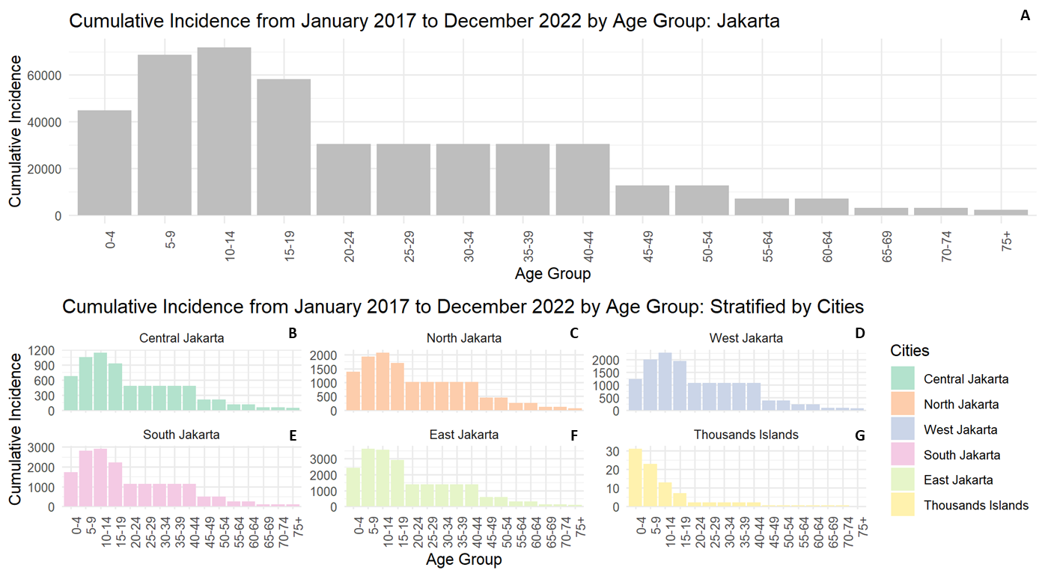

**Figure 3.** Cumulative incidence stratified by age from January 2017 to December 2022 (A-G). The Special Capital Region of Jakarta (A), and of its administrative regions of Central Jakarta (B), East Jakarta (C), North Jakarta (D), Thousand Islands (E), South Jakarta (F), and West Jakarta (G).

Jakarta, officially the Special Capital Region of Jakarta, administratively consists of 5 cities—Central Jakarta, North Jakarta, West Jakarta, South Jakarta, East Jakarta—and 1 municipality—Thousand Islands. Given that the reported data from each of these administrative boundaries were categorised into various age intervals, a weighting process was applied to the monthly incidence data, considering the age intervals of 0-4 to 15-19 with a 5-year interval, 20-44 with a 25-year interval, and the remaining age groups with a 10-year interval. Upon analysing the 5-year cumulative incidence across different age groups, the breakpoint was obtained at the age group 10-14 (**fig. 3**), thereby, dividing the population into two age groups, 0-14 and 15-75+ years old.

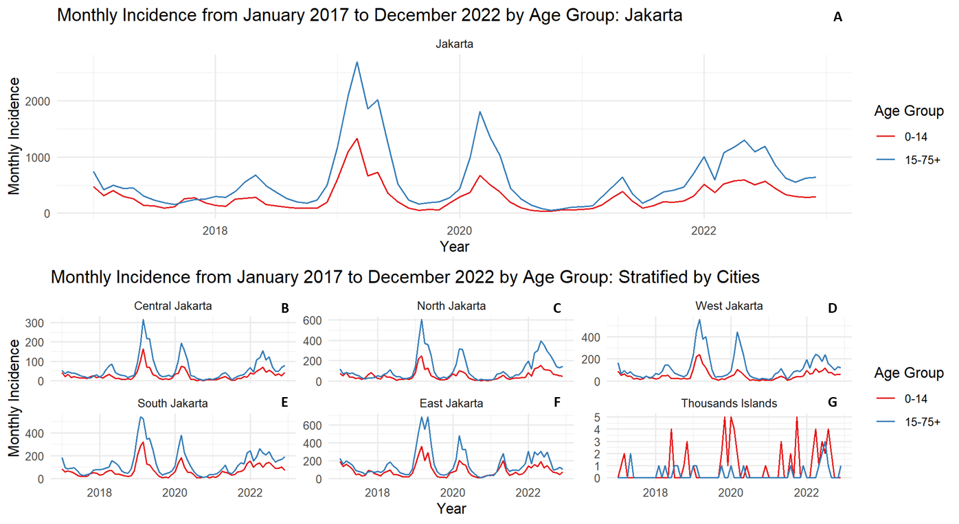

**Figure 4.** Reported monthly DHF incidence for age group A (0 to14) and age group B (15 to 75+)represented by red and blue lines, respectively (A-G). The monthly incidence of the Special Capital Region of Jakarta (A), and of its administrative regions of Central Jakarta (B), East Jakarta (C), North Jakarta (D), Thousand Islands (E), South Jakarta (F), and West Jakarta (G).

The monthly DHF incidence of the two age groups from the period of January 2017 to December 2022 were calculated (**fig. 4**). In this period, there was inter-annual variability in addition to monthly variability in terms of the peaks in all cities except in Thousand Islands Municipality. In Thousand Islands, there was no explicit inter-annual pattern observed as the number of cases are very small compared to the other cities. At the provincial level, the pattern was similar to what was observed in city level of Central Jakarta, East Jakarta, North Jakarta, South Jakarta, and West Jakarta. The highest annual peak occurred in 2019 followed by 2020.

The trend and the seasonality were similar in both age groups (**fig. S2 and S3)**. Each year, the DHF cases start to increase in January, then reach the highest period between March and May and start to drop in June before reaching lowest point around September and November. This cycle continues in a yearly manner, while the increasing interannual trend occurred biennially.

## 3.2. Model fitting

**Figure 5.** Simulated vs observed DHF dynamics; simulation results were run deterministically in monthly intervals over 45 years (the first 40 years simulations were discarded as transients, and the remaining 5 years (blue) were compared with the observed data from January 2017 to December 2022 (gray)) (a-b). (a) Simulated output of hospitalised DHF patients aged 0-14 years (blue) was fitted to the average DHF incidence stratified by month over 5 years (red). (b) Simulated output of hospitalised DHF patients aged 15-75+ years was fitted to the average DHF incidence stratified by month over 5 years (red). The population used for the model were PA = 2,739,633 and PB = 8,521,692 for age group A and B, respectively; transmission rate for group A, βA = 0.501, and group B, βB = 0.071; infectious period 1/𝜏 = 14 days; temporary immune waning rate, ω = 1/365 days-1; death rate for group A, μA = 1/70 years-1, and group B, μB = 1/50; cases importation rate, m = 1x10-6 day-1 per serotype, phase angle of group A and B, ΦA and ΦB = 8.50 months.

The model was fitted to the case notification data of hospitalised DHF that were averaged by month to calibrate 8 parameters: βA, βB, εA, εB, h.dhfA, hdhfB, ΦA and ΦB. The input parameters are summarised in **table S1**, respectively. The deterministic outputs of the fitted model were able to capture the average dynamics of hospitalised DHF cases in both age groups which occurred around the first half of each year (**fig. 5)**. These outputs would be used for the baseline scenario.It was also estimated from the model fitting that the average seroprevalence rate in group A was 70% while the overall seroprevalence in the population was 97%. Using equation (1) and the target of vaccination was at 88%, the vaccination coverage achieved would be 62%.

## 3.3. Scenario analysis

**Table 3**. Detailed description of each scenario along with the number of vaccines and screening needed in the population.

|  |  |  |  |  |  |  |  |
| --- | --- | --- | --- | --- | --- | --- | --- |
| **Scenario** | **Screening description** | **Vaccination description** | **Vaccine coverage** | **Screening coverage** | **DHF cases averted in age group A** | **DHF cases averted in age group B** | **Total DHF cases averted** |
| 1 | Screening: Yes, to all 0-14 years old children prior Dengvaxia vaccination | Vaccine:  Dengvaxia only to seropositive children aged 0-14 years old.  Vaccine coverage: 74% | 62% | 92% | 66% | 66% | 66% |
| 2 | Screening: No | Vaccine:  Qdenga to all children aged 0-14 years old regardless their serostatus.  Vaccine coverage: 74% | 62% | 0% | 35% | 28% | 30% |
| 3 | Screening: Yes, to all 0-14 years old children prior Qdenga vaccination | Vaccine:  Qdenga only to seropositive children aged 0-14 years old.  Vaccine coverage: 74% | 62% | 92% | 48% | 46% | 47% |
| 4 | Screening: Yes, only to 0-14 years old children prior Dengvaxia vaccination | Vaccine:   * Dengvaxia to seropositive children aged 0-14 years old. * Qdenga to children aged 0-14 years old regardless their serostatus.   Vaccine coverage: 74% (50:50) | 62% | 46% | 43% | 38% | 40% |
| 5 | Screening: Yes, to all 0-14 years old children prior Dengvaxia or Qdenga vaccination | Vaccine:   * Dengvaxia to seropositive children aged 0-14 years old. * Qdenga to children aged 0-14 years old regardless their serostatus.   Vaccine coverage: 74% (50:50) | 62% | 92% | 63% | 63% | 63% |

50:50 means the probability of getting Qdenga or Dengvaxia among children is 50% for both vaccines so that each vaccine accounts for a half of the vaccination coverage. A child can only get either Qdenga or Dengvaxia vaccines upon vaccination.

The model was run to analyse the importance of screening prior Qdenga vaccination. The results are summarised in **table 3**. Based on the input of vaccine efficacy profiles of both vaccines in table 1, all vaccination scenarios showed that targeting specific population can eventually reduce DHF burden in the overall population. In Dengvaxia only (scenario 1), it had the most cumulative DHF cases averted after 3 years at 66%. Meanwhile, Qdenga vaccines without screening (scenario 2) reduced 3-year cumulative DHF cases by 30%, which was lower compared to when screening was implemented (scenario 3) at 47%. Similarly, when both Qdenga and Dengvaxia vaccines were used in the population, screening only to Dengvaxia but not to Qdenga (scenario 4) reduced total DHF cases by 40%, while applying pre-vaccination prior receiving either vaccine (scenario 5) can improve the DHF reduction to 63%.

## 3.4. Sensitivity analysis

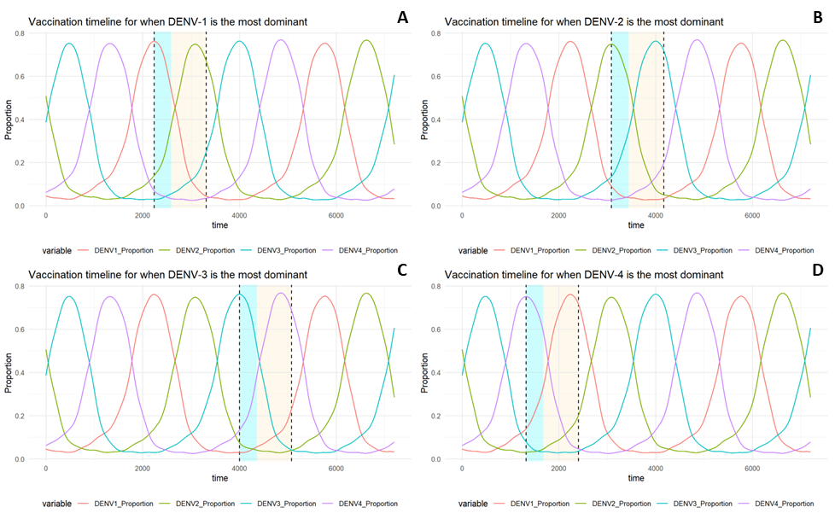

**Figure 6.** Four different vaccination timings (a-d). The vaccination timings were varied based on the dynamics of the circulating dynamics: when the dominating serotype was DENV-1, started at t = 1321 (a), DENV-2, started at t = 2234 (b), DENV-3, started at t = 3084 (c), and DENV-4, started at t = 3998 (d).

**Figure 7**. The sensitivity analysis result across 5 different scenarios. The vaccination period was selected based on the time when most dominant DENV serotype occurred, e.g., timing 1 corresponded to when DENV-1 was the prevailing circulating serotype.

The sensitivity analysis demonstrated that across four different vaccination campaign timings (**fig. 6**), the screening scenario consistently yielded better outcomes compared to its counterpart scenario, as shown in scenario 2 versus scenario 3, and scenario 4 versus scenario 5 (f**ig. 7**). Among all four different assumptions, scenario 2 consistently yielded the lowest outcome among the five scenarios. Within the same scenario, at four different timings, variations were also shown, suggesting that the dynamics of circulating serotypes may influence the overall impact three years after the vaccination campaign had started. The variation was the most significant in scenario 2, the scenario where screening was not implemented at all.

More importantly, we demonstrated significant differences between screening vs non-screening scenarios of Qdenga vaccination, across four different timings (20% vs 63%, 7% vs 68%, 1% vs 64%, 6% vs 61% in timing 1, 2, 3, and 4, respectively). The detailed result is summarised in the supplement (**table. S2**)and fig. S4-S8.

# 4. Discussion

## 4.1. Principal summary of findings

Based on the distribution of cases across age groups, we stratified the dengue transmission model to account for two age group from 0 to 14 and 15-75+ years old and consider the seroprevalence rate among those under 15 years of age to be at 70%. In both sub-populations, the average intra-annual seasonality suggested that an upsurge in dengue cases was likely to occur between March and May, while the inter-annual peak occurred biennially. Scenario analysis demonstrated that a better outcome could be achieved through the implementation of screening. However, it is important to note that the overall effectiveness may be influenced by the concurrent circulating serotypes during vaccination campaign.

## 4.2. Interpretation of results and implication to policy

We did not attempt to conclude the optimal scenarios to yield the maximum impact, rather, we demonstrated that not implementing pre-vaccination screening prior Qdenga vaccination in Jakarta might negatively affect the impact of the vaccination programme. Additionally, the vaccines allocated only to age group 0-14 can reduce the overall transmission by reducing a number of infected people at a time, thereby, the overall transmission risk would eventually be reduced. The model was calibrated according to the high dengue transmission in Jakarta that was characterised by the average seroprevalence levels in age group 0 to 14 at 70%, which was constructed with the seroprevalence finding on other studies (31,41). It should be noted that dengue transmission was geographically varied (42); therefore, we should take into account that dengue vaccination may be undesirable in some particular settings, e.g., in area with low-transmission of dengue (29).

To ensure fair comparison across vaccination scenarios, a fixed vaccination coverage was applied across all scenarios. This approach was adopted to prevent obscuring whether outcome differences were due to vaccine quantity or allocation methods. The main objective of pre-vaccination screening was to optimise vaccine distribution for seropositive individuals. Consequently, in the screening scenario, the majority of vaccines were allocated to individuals with a history of previous dengue infection. This contrasts with scenarios without screening, where vaccines were proportionally distributed among seronegative and seropositive individuals.

Based on strategic approach of maximising vaccine allocation to seropositive individuals while minimising vaccination in seronegative individuals appears promising to achieve the maximum desired outcomes, especially in the context to achieve efficiency in resource allocation. In the context of dengue vaccines, beyond demonstrating a favourable efficacy profile, pre-vaccination screening may increase the potential to improves vaccination effectiveness in the population (43). This improvement primarily arises from two key factors. Firstly, pre-vaccination screening can help minimise the probability of acquiring DHF due to ADE, particularly when vaccine administration might be associated with an increased risk of ADE among seronegative individuals. Secondly, even in situations where the vaccine does not pose an elevated ADE risk, pre-vaccination screening can optimise vaccine effectiveness by directing vaccination preferentially to seropositive individuals, as inherent vaccine efficacy profiles indicate a higher level of efficacy in this subgroup compared to seronegative individuals (26,44).

However, the optimisation process should consider the economic aspects and resource constraints. Therefore, a comprehensive economic evaluation becomes indispensable to assess the feasibility and cost-effectiveness of this approach, allowing for informed decision-making in vaccine distribution and administration. Recent study in Indonesia showed that pre-vaccination screening would be actually cost-effective but unaffordable to be implemented as it may require a huge cost for such a programme (32). Some other alternatives include a breakthrough method by utilising *Wolbachia* bacteria as a means of controlling dengue transmission (45), which might also be effective in reducing dengue burden and cost-effective (4,46).

It might be important to note that the VE of presently available vaccines depends on both the infecting serotypes and the serostatus of the vaccinees (25,26,44). With the availability of serotype-specific VE data, the use of the Duke model enabled us to assess how the dynamics of circulating serotypes could impact the dengue vaccination strategy, in conjunction with pre-vaccination screening. We have incorporated this assumption into our sensitivity analysis, and all scenarios consistently showed the screening scenario consistently yielded better outcomes compared to its counterpart scenario, thus confirming the robustness of our analysis favouring screening to be implemented.

However, the output from this model does not exclude the possibility of other immunological and ecological factors influencing the dynamics of dengue disease. Alongside factors like transmission through mosquito vectors, the virus amplification rate, and population density, climate variability also plays a crucial role (47). The abundance and longevity of mosquito vectors, as well as the virus transmission dynamics, are significantly affected by temperature, rainfall, and humidity, making climate variability one of the most important additional factors regulating dengue dynamics (48,49). A recent study successfully formulated a proxy of female mosquito vector’s transmission potential that is highly correlated with climate inputs worldwide (50). Consequently, future studies may be needed to consider the interplay of multiple factors, including immunological, ecological, and climatic variables as a means to achieve more comprehensive understanding of dengue disease dynamics.

The fluctuation of circulating DENV serotypes over time might also impact the overall outcome of the vaccination programme at different intervals. DENV serotypes exhibit genetic diversity (51,52). This factor, along with the fluctuating serotype-specific seroprevalence in the population (53,54), complex heterologous immunity interplay (55), and the varying VE of dengue vaccines (25,26,44), adds to the complexity of the dengue disease transmission dynamics and our understanding of immunity in dengue.

Moreover, randomized controlled trial (RCT) data have highlighted significant differences in Qdenga vaccine efficacy among seronegative recipients. The highest efficacy was observed against DENV-2, followed by DENV-1, while efficacy against DENV-3 and DENV-4 was less favourable (26). Conversely, efficacy remained consistently high across all serotypes for seropositive recipients (26). As a result, considering a reduction in vaccine allocation to seronegative individuals might help minimise the risk of secondary-like DHF and counteract the negative efficacy against certain serotypes.

## 4.3. Limitation

This study was subject to several limitations. First, Jakarta surveillance system data were limited only from January 2017 onwards; thus, the extended analyses of the disease's interannual dynamics and trends a few years or even decades in advance became limited. The availability of age-stratified reports over the years would allow analyses of the impact of the changing transmission potential on disease dynamics as well as improving the right parameters to be implemented in the fitted model. Secondly, up to the point where this manuscript is written, no data regarding VE against dengue infection exists. We implemented the VE data against VCD as if it were against dengue infection to account for the changing of the circulating serotypes. Although this approach was not ideal, this attempt may provide some insight on how the proportion of the existing serotypes affects the public health outcome and vice versa, suggesting that heterogeneity of the DENV serotypes in a population, in addition to seroprevalence, might be an important factor to be considered before determining which and how vaccines should be implemented in a particular setting.

Additionally, we attempted to just divide population into two instead of stratifying the population into several age groups. This would restrict the extended analysis on how seroprevalence varied between each age group. For example, 70% seroprevalence modelling in this work was the average seroprevalence of the age 0-14 years old. Meanwhile, age stratification may allow us to evaluate further both direct and indirect impact of the vaccination programme, thereby, increasing accuracy of the results (56).

## 4.4. Conclusion

In high dengue transmission settings, such as in Jakarta, it may be useful to consider pre-vaccination screening to be implemented prior to receiving Dengvaxia or Qdenga vaccines. It may act to improve vaccination impact by reducing the risk of severe dengue from ADE, particularly in seronegative individuals, and prioritising seropositive individuals can optimise the public health impact through reduction of DHF cases. However, economic evaluation is recommended for resource-constrained vaccination programmes that incorporate pre-vaccination screening. Future models that account for more detailed immune and climate variables as well as more extensive age stratification are recommended, as they can also help to address some aspects that were not covered in this work.

# 5. Supplementary Information

All supplementary materials referenced throughout this report are attached as an additional file.

## 5.1. Author Contributions

Conceptualisation: Nando Reza Pratama, Hannah Eleanor Clapham

Formal Analysis: Nando Reza Pratama

Methodology: Nando Reza Pratama, Hannah Eleanor Clapham

Supervision: Hannah Eleanor Clapham

Writing – original draft: Nando Reza Pratama

Writing – review & editing: Nando Reza Pratama, Hannah Eleanor Clapham

## 5.2. Competing Interest

The author declares that no competing interests exist.

## 5.3. Financial Disclosure

The authors received no specific funding for this work.

## 5.4. Data Availability

All data used in the model is attached as supplementary and made publicly available on Github at <https://github.com/dissertation-mgh/MGH-Dissertation>.

## 5.5. Code Availability

The model that supported the empirical estimates produced in this study was coded in R version 4.2.3. and is available on Github at <https://github.com/dissertation-mgh/MGH-Dissertation>.

## 5.6. Supporting Information Caption

Appendix S1. The transmission and vaccination model.

Appendix S2. Data.

Appendix S3. Initial conditions.

Figure S1. The overall workflow of the analysis. The overall workflow of the analysis. The analysis started with data training which consists of the characterising of case notification data in order to divide the population into two age groups before the seasonality of monthly DHF cases was averaged by month (first box). The transmission model was then run for 45 years, while the first 40 years was discarded, and the remaining 5 years was fitted with the data by minimising negative log-likelihood following Poisson distribution. Then, seroprevalence rate, vaccine coverage, and screening coverage were all calculated for modelling vaccination (second box). In the vaccination model, the model was run in order to evaluate the total hospitalised DHF cases averted after 3 years (third box). The sensitivity analysis was performed by adjusting the vaccination timing according to each period where the each DENV serotype was the highest in terms of its proportion. Then, the vaccination scenario was run according to each timing and the number of hospitalised DHF cases was recalculated (fourth box).

Figure S2. The trajectories of the trend and the seasonality of monthly reported DHF cases of those aged 0 - 14 years.

Figure S3. The trajectories of the trend and the seasonality of monthly reported DHF cases of those aged 15 to 75+ years.

Figure S4. The resulting DENV-1 to DENV-4 serotype dominance following vaccination in scenario 1.

Figure S5. The resulting DENV-1 to DENV-4 serotype dominance following vaccination in scenario 2.

Figure S6. The resulting DENV-1 to DENV-4 serotype dominance following vaccination in scenario 3.

Figure S7. The resulting DENV-1 to DENV-4 serotype dominance following vaccination in scenario 4.

Figure S8. The resulting DENV-1 to DENV-4 serotype dominance following vaccination in scenario 5.

Supplementary figures.

Supplementary figures.

Table S1. The list of parameters used in the model.

Table S2. Outcomes of each scenario across 4 different assumptions.

# 6. References

1. Murugesan A, Manoharan M. Dengue Virus. In: Emerging and Reemerging Viral Pathogens [Internet]. Elsevier; 2020 [cited 2023 Aug 8]. p. 281–359. Available from: https://linkinghub.elsevier.com/retrieve/pii/B9780128194003000168

2. World Health Organization, editor. Comprehensive guidelines for prevention and control of dengue and dengue haemorrhagic fever. Rev. and expanded. ed. New Delhi, India: World Health Organization Regional Office for South-East Asia; 2011. 196 p. (SEARO Technical publication series).

3. Bhatt S, Gething PW, Brady OJ, Messina JP, Farlow AW, Moyes CL, et al. The global distribution and burden of dengue. Nature. 2013 Apr;496(7446):504–7.

4. O’Reilly KM, Hendrickx E, Kharisma DD, Wilastonegoro NN, Carrington LB, Elyazar IRF, et al. Estimating the burden of dengue and the impact of release of wMel Wolbachia-infected mosquitoes in Indonesia: a modelling study. BMC Med. 2019 Dec;17(1):172.

5. Guzman MG, Gubler DJ, Izquierdo A, Martinez E, Halstead SB. Dengue infection. Nat Rev Dis Primers. 2016 Dec 22;2(1):16055.

6. Imrie A, Meeks J, Gurary A, Sukhbaatar M, Truong TT, Cropp CB, et al. Antibody to Dengue 1 Detected More Than 60 Years after Infection. Viral Immunology. 2007 Dec;20(4):672–5.

7. Murrell S, Wu SC, Butler M. Review of dengue virus and the development of a vaccine. Biotechnology Advances. 2011 Mar;29(2):239–47.

8. Forshey BM, Reiner RC, Olkowski S, Morrison AC, Espinoza A, Long KC, et al. Incomplete Protection against Dengue Virus Type 2 Re-infection in Peru. Messer WB, editor. PLoS Negl Trop Dis. 2016 Feb 5;10(2):e0004398.

9. Waggoner JJ, Balmaseda A, Gresh L, Sahoo MK, Montoya M, Wang C, et al. Homotypic Dengue Virus Reinfections in Nicaraguan Children. J Infect Dis. 2016 Oct 1;214(7):986–93.

10. Cummings DAT, Iamsirithaworn S, Lessler JT, McDermott A, Prasanthong R, Nisalak A, et al. The Impact of the Demographic Transition on Dengue in Thailand: Insights from a Statistical Analysis and Mathematical Modeling. Farrar J, editor. PLoS Med. 2009 Sep 1;6(9):e1000139.

11. Guzmán MG, Kouri G, Bravo J, Valdes L, Susana V, Halstead SB. Effect of age on outcome of secondary dengue 2 infections. International Journal of Infectious Diseases. 2002 Jun;6(2):118–24.

12. Anderson KB, Gibbons RV, Cummings DAT, Nisalak A, Green S, Libraty DH, et al. A Shorter Time Interval Between First and Second Dengue Infections Is Associated With Protection From Clinical Illness in a School-based Cohort in Thailand. The Journal of Infectious Diseases. 2014 Feb 1;209(3):360–8.

13. Sabin AB. Research on Dengue during World War II. Am J Trop Med. 1952 Jan;1(1):30–50.

14. Katzelnick LC, Gresh L, Halloran ME, Mercado JC, Kuan G, Gordon A, et al. Antibody-dependent enhancement of severe dengue disease in humans. Science. 2017 Nov 17;358(6365):929–32.

15. St. John AL, Rathore APS. Adaptive immune responses to primary and secondary dengue virus infections. Nat Rev Immunol. 2019 Apr;19(4):218–30.

16. Midgley CM, Bajwa-Joseph M, Vasanawathana S, Limpitikul W, Wills B, Flanagan A, et al. An In-Depth Analysis of Original Antigenic Sin in Dengue Virus Infection. J Virol. 2011 Jan;85(1):410–21.

17. Katzelnick LC, Montoya M, Gresh L, Balmaseda A, Harris E. Neutralizing antibody titers against dengue virus correlate with protection from symptomatic infection in a longitudinal cohort. Proc Natl Acad Sci USA. 2016 Jan 19;113(3):728–33.

18. Takeda. Takeda’s QDENGA®▼ (Dengue Tetravalent Vaccine [Live, Attenuated]) Approved for Use in European Union [Internet]. Takeda; 2022 [cited 2023 Aug 8]. Available from: https://www.takeda.com/newsroom/newsreleases/2022/takedas-qdenga-dengue-tetravalent-vaccine-live-attenuated-approved-for-use-in-european-union/

19. Takeda. Takeda’s QDENGA®▼ (Dengue Tetravalent Vaccine [Live, Attenuated]) Approved in Indonesia for Use Regardless of Prior Dengue Exposure [Internet]. Takeda; 2022 [cited 2023 Aug 8]. Available from: https://www.takeda.com/newsroom/newsreleases/2022/takedas-qdenga-dengue-tetravalent-vaccine-live-attenuated-approved-in-indonesia-for-use-regardless-of-prior-dengue-exposure/

20. European Medicine Agency. Dengvaxia [Internet]. European Medicine Agency; 2019 [cited 2023 Aug 8]. Available from: https://www.ema.europa.eu/en/medicines/human/EPAR/dengvaxia

21. WHO. Dengue vaccines: WHO position paper - September 2018. Weekly epidemiological record. 2018;90(36):457–76.

22. Biswal S, Borja-Tabora C, Martinez Vargas L, Velásquez H, Theresa Alera M, Sierra V, et al. Efficacy of a tetravalent dengue vaccine in healthy children aged 4–16 years: a randomised, placebo-controlled, phase 3 trial. The Lancet. 2020 May;395(10234):1423–33.

23. Biswal S, Reynales H, Saez-Llorens X, Lopez P, Borja-Tabora C, Kosalaraksa P, et al. Efficacy of a Tetravalent Dengue Vaccine in Healthy Children and Adolescents. N Engl J Med. 2019 Nov 21;381(21):2009–19.

24. Capeding MR, Tran NH, Hadinegoro SRS, Ismail HIHM, Chotpitayasunondh T, Chua MN, et al. Clinical efficacy and safety of a novel tetravalent dengue vaccine in healthy children in Asia: a phase 3, randomised, observer-masked, placebo-controlled trial. The Lancet. 2014 Oct;384(9951):1358–65.

25. Hadinegoro SR, Arredondo-García JL, Capeding MR, Deseda C, Chotpitayasunondh T, Dietze R, et al. Efficacy and Long-Term Safety of a Dengue Vaccine in Regions of Endemic Disease. N Engl J Med. 2015 Sep 24;373(13):1195–206.

26. Rivera L, Biswal S, Sáez-Llorens X, Reynales H, López-Medina E, Borja-Tabora C, et al. Three-year Efficacy and Safety of Takeda’s Dengue Vaccine Candidate (TAK-003). Clinical Infectious Diseases. 2022 Aug 24;75(1):107–17.

27. Villar L, Dayan GH, Arredondo-García JL, Rivera DM, Cunha R, Deseda C, et al. Efficacy of a Tetravalent Dengue Vaccine in Children in Latin America. N Engl J Med. 2015 Jan 8;372(2):113–23.

28. Shukla R, Ramasamy V, Shanmugam RK, Ahuja R, Khanna N. Antibody-Dependent Enhancement: A Challenge for Developing a Safe Dengue Vaccine. Front Cell Infect Microbiol. 2020 Oct 22;10:572681.

29. Flasche S, Jit M, Rodríguez-Barraquer I, Coudeville L, Recker M, Koelle K, et al. The Long-Term Safety, Public Health Impact, and Cost-Effectiveness of Routine Vaccination with a Recombinant, Live-Attenuated Dengue Vaccine (Dengvaxia): A Model Comparison Study. von Seidlein L, editor. PLoS Med. 2016 Nov 29;13(11):e1002181.

30. Mallapaty S. Dengue vaccine poised for roll-out but safety concerns linger. Nature [Internet]. 2022 Nov 11; Available from: https://www.nature.com/articles/d41586-022-03546-2

31. O’Driscoll M, Imai N, Ferguson NM, Hadinegoro SR, Satari HI, Tam CC, et al. Spatiotemporal variability in dengue transmission intensity in Jakarta, Indonesia. Azman AS, editor. PLoS Negl Trop Dis. 2020 Mar 6;14(3):e0008102.

32. Suwantika AA, Supadmi W, Ali M, Abdulah R. Cost-effectiveness and budget impact analyses of dengue vaccination in Indonesia. Forshey BM, editor. PLoS Negl Trop Dis. 2021 Aug 12;15(8):e0009664.

33. Nagao Y, Koelle K. Decreases in dengue transmission may act to increase the incidence of dengue hemorrhagic fever. Proc Natl Acad Sci USA. 2008 Feb 12;105(6):2238–43.

34. Kraiselburd E, Gubler DJ, Kessler MJ. Quantity of dengue virus required to infect rhesus monkeys. Transactions of the Royal Society of Tropical Medicine and Hygiene. 1985 Jan;79(2):248–51.

35. Kochel TJ, Watts DM, Gozalo AS, Ewing DF, Porter KR, Russell KL. Cross‐Serotype Neutralization of Dengue Virus in *Aotus* *nancymae* Monkeys. J INFECT DIS. 2005 Mar 15;191(6):1000–4.

36. Salje H, Cummings DAT, Rodriguez-Barraquer I, Katzelnick LC, Lessler J, Klungthong C, et al. Reconstruction of antibody dynamics and infection histories to evaluate dengue risk. Nature. 2018 May;557(7707):719–23.

37. Endy TP, Srikiatkhachorn A, Jarman RG, Mammen MP, Vaughn DW, Kalanarooj S, et al. Analysis of Repeat Hospital Admissions for Dengue to Estimate the Frequency of Third or Fourth Dengue Infections Resulting in Admissions and Dengue Hemorrhagic Fever, and Serotype Sequences. The American Journal of Tropical Medicine and Hygiene. 2007 Nov 1;77(5):910–3.

38. Health Department of Jakarta. Seksi Surveilans Epidemiologi dan Imunisasi [Internet]. 2023 [cited 2023 Aug 8]. Available from: https://surveilans-dinkes.jakarta.go.id/sarsbaru/index.php

39. Ministry of Health, Republic of Indonesia. Health Profile of Indonesia 2009–2018. 2018.

40. Lopez AL, Adams C, Ylade M, Jadi R, Daag JV, Molloy CT, et al. Determining dengue virus serostatus by indirect IgG ELISA compared with focus reduction neutralisation test in children in Cebu, Philippines: a prospective population-based study. The Lancet Global Health. 2021 Jan;9(1):e44–51.

41. Tam CC, O’Driscoll M, Taurel AF, Nealon J, Hadinegoro SR. Geographic variation in dengue seroprevalence and force of infection in the urban paediatric population of Indonesia. Horstick O, editor. PLoS Negl Trop Dis. 2018 Nov 2;12(11):e0006932.

42. Leta S, Beyene TJ, De Clercq EM, Amenu K, Kraemer MUG, Revie CW. Global risk mapping for major diseases transmitted by Aedes aegypti and Aedes albopictus. International Journal of Infectious Diseases. 2018 Feb;67:25–35.

43. Wilder-Smith A, Peeling RW. Optimising dengue pre-vaccination screening. The Lancet Infectious Diseases. 2021 Apr;21(4):442–4.

44. Dorigatti I, Donnelly CA, Laydon DJ, Small R, Jackson N, Coudeville L, et al. Refined efficacy estimates of the Sanofi Pasteur dengue vaccine CYD-TDV using machine learning. Nat Commun. 2018 Sep 7;9(1):3644.

45. Utarini A, Indriani C, Ahmad RA, Tantowijoyo W, Arguni E, Ansari MR, et al. Efficacy of Wolbachia-Infected Mosquito Deployments for the Control of Dengue. N Engl J Med. 2021 Jun 10;384(23):2177–86.

46. Brady OJ, Kharisma DD, Wilastonegoro NN, O’Reilly KM, Hendrickx E, Bastos LS, et al. The cost-effectiveness of controlling dengue in Indonesia using wMel Wolbachia released at scale: a modelling study. BMC Med. 2020 Dec;18(1):186.

47. Van Panhuis WG, Choisy M, Xiong X, Chok NS, Akarasewi P, Iamsirithaworn S, et al. Region-wide synchrony and traveling waves of dengue across eight countries in Southeast Asia. Proc Natl Acad Sci USA. 2015 Oct 20;112(42):13069–74.

48. Xu L, Stige LC, Chan KS, Zhou J, Yang J, Sang S, et al. Climate variation drives dengue dynamics. Proc Natl Acad Sci USA. 2017 Jan 3;114(1):113–8.

49. Yang B, Borgert BA, Alto BW, Boohene CK, Brew J, Deutsch K, et al. Modelling distributions of Aedes aegypti and Aedes albopictus using climate, host density and interspecies competition. Barker CM, editor. PLoS Negl Trop Dis. 2021 Mar 25;15(3):e0009063.

50. Nakase T, Giovanetti M, Obolski U, Lourenço J. Global transmission suitability maps for dengue virus transmitted by Aedes aegypti from 1981 to 2019. Sci Data. 2023 May 12;10(1):275.

51. Yenamandra SP, Koo C, Chiang S, Lim HSJ, Yeo ZY, Ng LC, et al. Evolution, heterogeneity and global dispersal of cosmopolitan genotype of Dengue virus type 2. Sci Rep. 2021 Jun 29;11(1):13496.

52. Bell SM, Katzelnick L, Bedford T. Dengue genetic divergence generates within-serotype antigenic variation, but serotypes dominate evolutionary dynamics. eLife. 2019 Aug 6;8:e42496.

53. Cox V, O’Driscoll M, Imai N, Prayitno A, Hadinegoro SR, Taurel AF, et al. Estimating dengue transmission intensity from serological data: A comparative analysis using mixture and catalytic models. Wu JT, editor. PLoS Negl Trop Dis. 2022 Jul 11;16(7):e0010592.

54. Reiner RC, Stoddard ST, Forshey BM, King AA, Ellis AM, Lloyd AL, et al. Time-varying, serotype-specific force of infection of dengue virus. Proc Natl Acad Sci USA [Internet]. 2014 Jul [cited 2023 Aug 21];111(26). Available from: https://pnas.org/doi/full/10.1073/pnas.1314933111

55. Aguas R, Dorigatti I, Coudeville L, Luxemburger C, Ferguson NM. Cross-serotype interactions and disease outcome prediction of dengue infections in Vietnam. Sci Rep. 2019 Jun 28;9(1):9395.

56. Eichner M, Schwehm M, Eichner L, Gerlier L. Direct and indirect effects of influenza vaccination. BMC Infect Dis. 2017 Dec;17(1):308.

57. Guzman MG. Epidemiologic Studies on Dengue in Santiago de Cuba, 1997. American Journal of Epidemiology. 2000 Nov 1;152(9):793–9.

58. Chan M, Johansson MA. The Incubation Periods of Dengue Viruses. Vasilakis N, editor. PLoS ONE. 2012 Nov 30;7(11):e50972.

**Table S1**. The list of parameters used in the model.

|  |  |  |  |  |
| --- | --- | --- | --- | --- |
| **name** | **value** | **unit** | **description** | **References** |
| m | 0.000001 | day-1 | immigration rate | (33) |
| εA | 0.212 | - | seasonal forcing at age group A | Model fitting |
| εB | 0.185 | - | seasonal forcing at age group B | Model fitting |
| μA | 1/70 | year-1 | human death rate at age group A | assumed |
| μB | 1/50 | year-1 | human death rate at age group B | assumed |
| ΦA | 8.50 | Month | Seasonal lag in age group A | Model fitting |
| ΦB | 8.50 | Month | Seasonal lag in age group B | Model fitting |
| ο | 1/365 | day-1 | Immune waning rate | (33) |
| βA | 0.501 | day-1 | Basic reproduction rate of group A | Model fitting |
| βB | 0.0714 | day-1 | Basic reproduction rate of group B | Model fitting |
| θi | 0.12 | - | proportion of 1st DHF to VCD | (12,57) |
| θij | 0.22 | - | proportion of 2nd DHF to VCD | (12,57) |
| φi | 0.10 | - | proportion of 1st DF to dengue infection | (12,57) |
| φij | 0.20 | - | proportion of 2nd DF to dengue infection | (12,57) |
| ρi | 0.78 | - | proportion of subclinical 1st dengue to dengue infection | (12,57) |
| ρij | 0.58 | - | proportion of subclinical 2nd dengue to dengue infection | (12,57) |
| πi | 0.22 | - | proportion of 1st VCD to dengue infection | (12,57) |
| πij | 0.42 |  | proportion of 2nd VCD to dengue infection | (12,57) |
| h.dhfi,A | 0.0297 | - | proportion of 1st DHF to dengue infection of group A (fitted) | Model fitting |
| h.dhfij,A | 0.0567 | - | proportion of 2nd DHF to dengue infection of group A (fitted) | Model fitting |
| h.dhfi,B | 0.0292 | - | proportion of 1st DHF to dengue infection of group B (fitted) | Model fitting |
| h.dhfij,B | 0.0572 | - | proportion of 2nd DHF to dengue infection of group B (fitted) | Model fitting |
| ω | 0.002739726 | - | Heterologous protective immunity waning rate | Assumed |
| τ | 1/14 | day-1 | Loss of infectiousness rate | (33,58) |
| μdhf | 0.007 | day-1 | Mortality rate of DHF cases | (38) |
| υ | 1/15 | year-1 | Ageing rate | Assumed |
| spec | 0.934 | - | Specificity of screening | (40) |
| sens | 0.952 | - | Specificity of screening | (40) |

**Table S2.** Outcomes of each scenario across 4 different assumptions.

|  |  |  |  |  |  |  |  |  |  |  |  |  |
| --- | --- | --- | --- | --- | --- | --- | --- | --- | --- | --- | --- | --- |
| Scenario | DHF cases averted in age group A | | | | DHF cases averted in age group B | | | | Total DHF cases averted | | | |
| Timing 1 | Timing 2 | Timing 3 | Timing 4 | Timing 1 | Timing 2 | Timing 3 | Timing 4 | Timing 1 | Timing 2 | Timing 3 | Timing 4 |
| 1 | 70% | 66% | 74% | 73% | 67% | 63% | 72% | 70% | 68% | 64% | 72% | 71% |
| 2 | 23% | 11% | 5% | 10% | 18% | 3% | -2% | 5% | 19% | 6% | 1% | 7% |
| 3 | 64% | 70% | 66% | 63% | 61% | 68% | 63% | 61% | 62% | 69% | 64% | 62% |
| 4 | 54% | 59% | 43% | 39% | 50% | 56% | 40% | 35% | 51% | 57% | 41% | 36% |
| 5 | 68% | 72% | 75% | 71% | 65% | 69% | 72% | 67% | 66% | 70% | 73% | 69% |

The scenario analysis was further analysed according to the dynamics that occurred during the vaccination campaign. The timing of the one-year vaccination programme was determined based on when the proportion of each serotype was at its highest. The evaluation took place three years after the programme started. The screening scenario consistently resulted in better outcomes compared to its counterpart, as demonstrated in scenario 2 versus scenario 3, and scenario 4 versus scenario 5. Across all four different assumptions, scenario 2 consistently produced the lowest outcome among the five scenarios.

**Figure S1.** The overall workflow of the analysis. The analysis started with data training which consists of the characterising of case notification data in order to divide the population into two age groups before the seasonality of monthly DHF cases was averaged by month (first box). The transmission model was then run for 45 years, while the first 40 years was discarded, and the remaining 5 years was fitted with the data by minimising negative log-likelihood following Poisson distribution. Then, seroprevalence rate, vaccine coverage, and screening coverage were all calculated for modelling vaccination (second box). In the vaccination model, the model was run in order to evaluate the total hospitalised DHF cases averted after 3 years (third box). The sensitivity analysis was performed by adjusting the vaccination timing according to each period where the each DENV serotype was the highest in terms of its proportion. Then, the vaccination scenario was run according to each timing and the number of hospitalised DHF cases was recalculated (fourth box).

**Figure S2.** The trajectories of the trend and the seasonality of monthly reported DHF cases of those aged 0 - 14 years.

**Figure S3.** The trajectories of the trend and the seasonality of monthly reported DHF cases of those aged 15 to 75+ years.

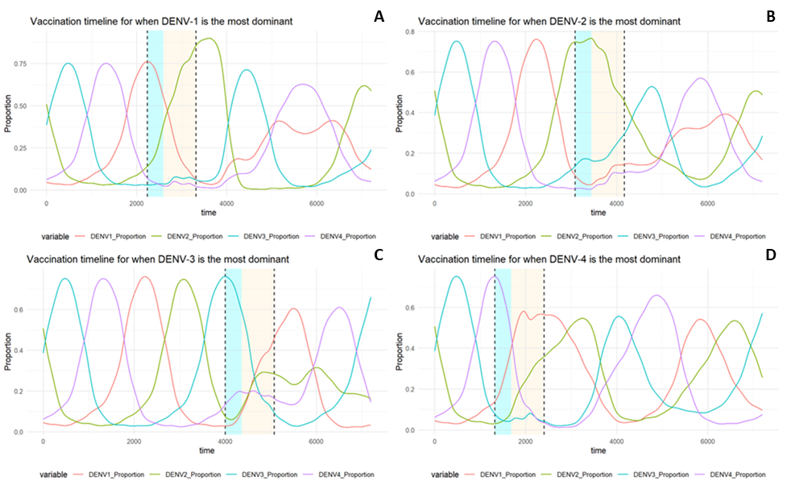

**Figure S4.** The resulting DENV-1 to DENV-4 serotype dominance following vaccination in scenario 1.

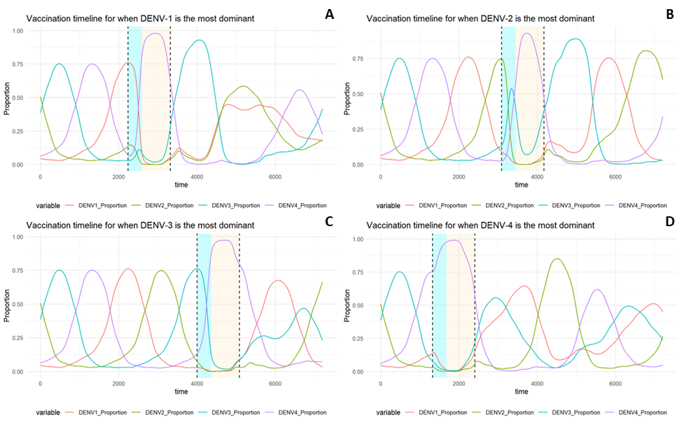

**Figure S5.** The resulting DENV-1 to DENV-4 serotype dominance following vaccination in scenario 2.

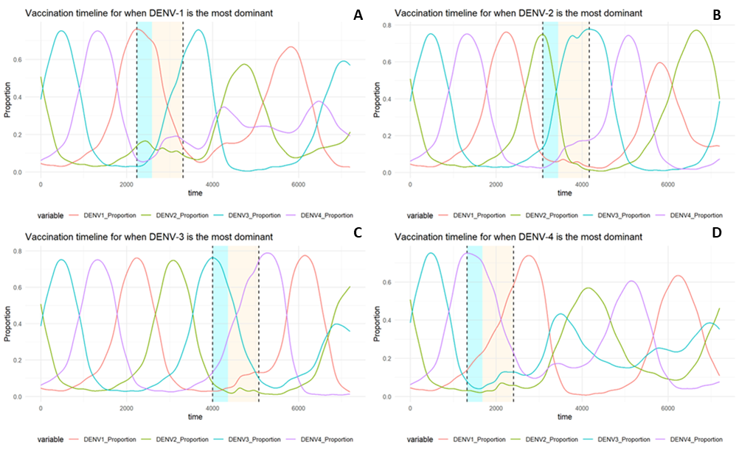

**Figure S6.** The resulting DENV-1 to DENV-4 serotype dominance following vaccination in scenario 3.

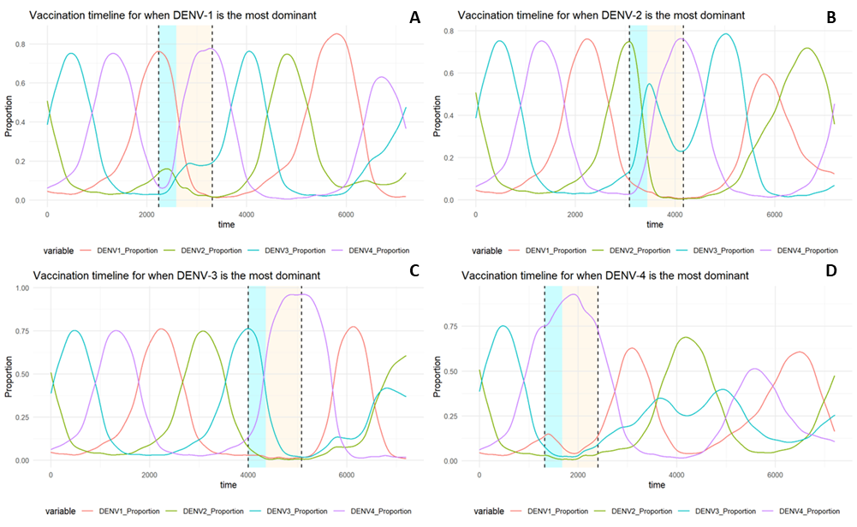

**Figure S7.** The resulting DENV-1 to DENV-4 serotype dominance following vaccination in scenario 4.

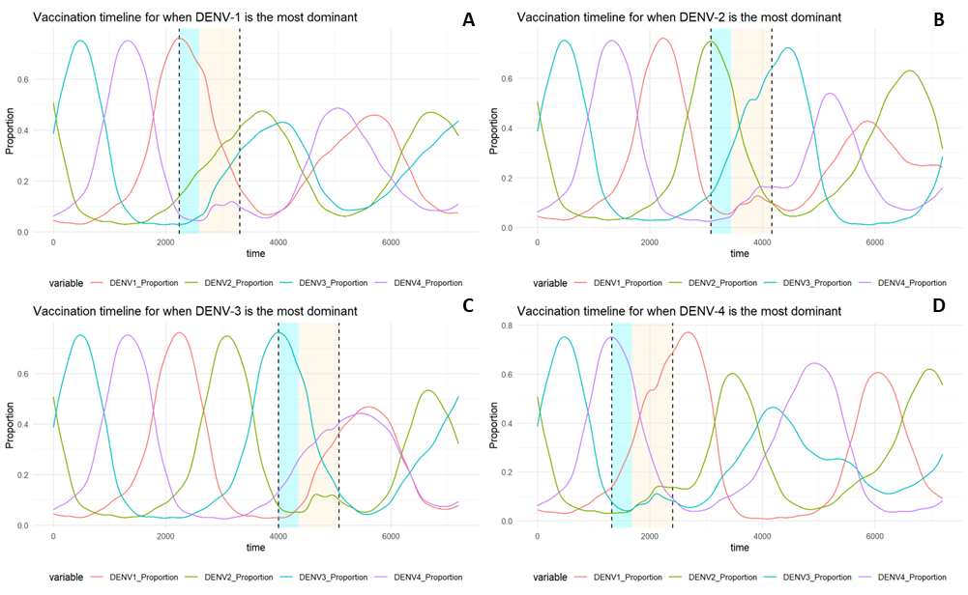

**Figure S8.** The resulting DENV-1 to DENV-4 serotype dominance following vaccination in scenario 5.